Pub Saving Award success after decade-long fight
02/01/2024 by Timothy Hampson
Campaign

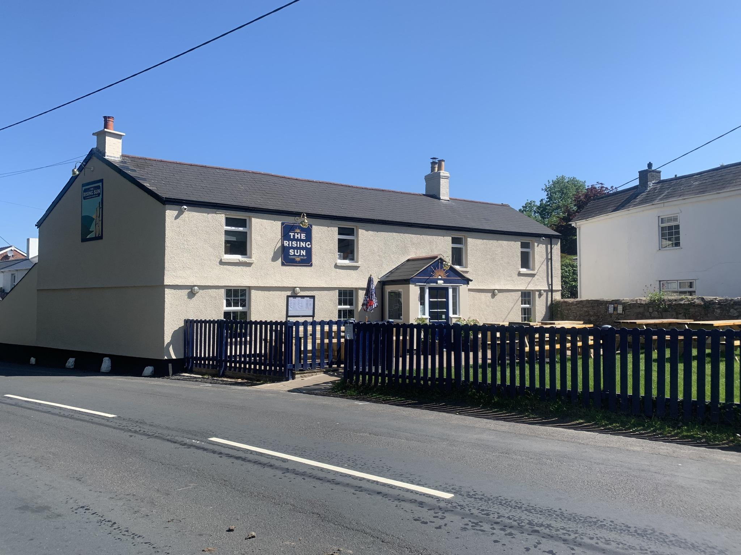

A community, which raised more than £350,000 to save the Rising Sun in Woodcroft, Chepstow, (above) has won CAMRA’s 2023 Pub Saving Award. The award recognises people that have come together to save a pub that would have otherwise been demolished or converted to another use. This year’s title has been awarded to the Save Our Sun committee for its decade of dedicated campaigning to save the pub and to provide a community hub. The Rising Sun appears on OS maps from 1870 and was brewery-owned in 2011 until high rents and beer costs caused its doors to close. Despite the community being informed that it had been bought as a pub in late 2012, it transpired that the new owner was a developer which wanted to turn it into residential property. This led to a community-led campaign to buy the pub. Started by a few locals in early 2013, the campaign finally reached fruition with the Rising Sun opening its doors again to the community in October 2022. Within one month of the community share option being launched, £350,000 had been raised from 240 investors. The group was also one of only two in England to be successful in obtaining a grant from the Community Ownership Fund of £175,000. Once given the keys to the pub, the community made a herculean effort to clean, repair and refurbish the building. With an amazing team of local tradespeople, a volunteer project manager and more than 120 volunteers all pitching in, the doors of the Rising Sun could open once again. The pub is now the centre of its community and is well supported by old and young. It is fully accessible, dog-friendly, serves food and drink, as well as providing space for volunteer activities including a subsidised community coffee morning. This year’s runner up is the White Horse in Stonesfield, Oxfordshire. The pub garnered support from across the pond, grabbing headlines in the New York Times and the Canadian Broadcasting Corporation, with funding coming from California and Connecticut as well as those in the local area. As the last remaining pub in the village, the community banded together to ensure the White Horse was safe from developers intent on turning it into housing. The pub is now operating as a pop-up until the new year, while extensive work takes place to ensure it returns to its former glory. The hundreds of hours of work from volunteers have not gone unnoticed and are worthy of recognition in this year’s Pub Saving Award. Three pubs were also highly commended: George in Bethersden, Kent. Saved by the George Community after closing during the pandemic, and now runs as a successful wet-led pub at the heart of its community. Raven Inn in Glazebury, Warrington. Campaigned for by the Save the Raven Group and backed by more than 1,200 supporters to restore it to its former glory. Travellers Rest in Skeeby, North Yorkshire. This opened its doors for the first time in almost 15 years after being saved from becoming a victim of redevelopment by a property developer. Chair of the Save Our Sun group Michelle Hayes said: “Thank you so much to CAMRA for recognising our community’s achievement in saving the Rising Sun after a rollercoaster nine-year campaign. “We were only able to realise our dream due to the incredible effort put in by volunteers, the generosity of local businesses, and receiving government and local grants. A huge thank you to all involved, we could not have done it without you. “We are thrilled and hope that our story will encourage and inspire other communities to do the same. Long live the community pub." CAMRA’s national planning policy adviser Paul Ainsworth said: “Every year, the stories of communities saving their pubs become more incredible. We’re very proud to award these groups with recognition in the Pub Saving Award and hope it will inspire others to take up the fight and save their locals. Congratulations to all who have been successful in giving these local pubs a new lease of life, and especially to the Rising Sun Woodcroft Community Pub group, whose story has moved us and hopefully plenty of others too. “These awards show the sheer determination and passion people have for their beloved pubs, a vitally important part of communities across the UK. Too many pubs are forced to close their doors against a backdrop of the cost-of-living crisis and soaring energy bills. Everyone recognised are an inspiration to others. I would encourage everyone to support their pubs, especially in the traditionally quieter post-Christmas period.” The pubs will be presented with their awards at events organised by their local CAMRA branches in early 2024.

