Triple treat from Greene King

23/05/2023 by Timothy Hampson

Industry

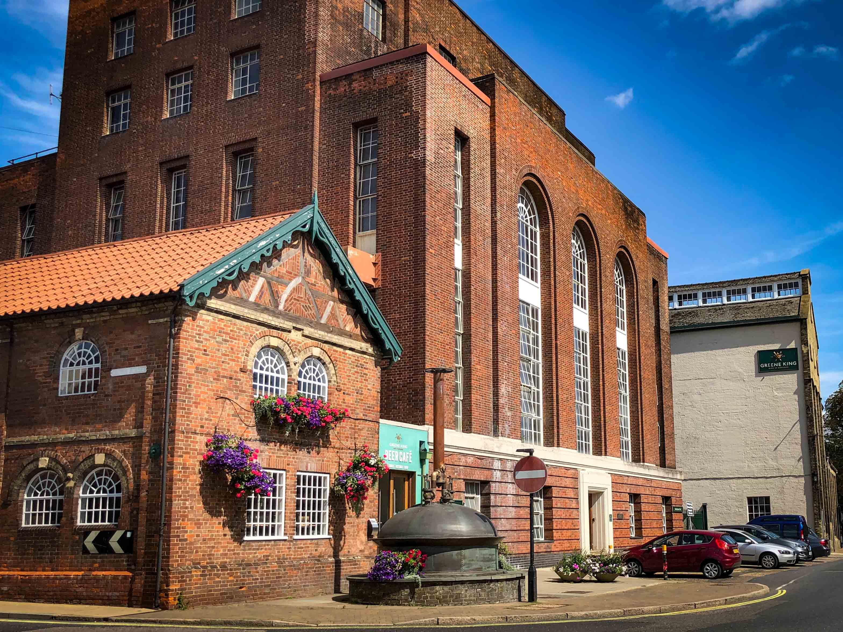

As well as its Coronation seasonal ale, Greene King will also be releasing a further three cask beers for May and June, which include a collaboration with Big Hug Brewing, a returning favourite and an ale inspired by hop picking. Pave The Way This 4.6 per cent pale ale is a new collaboration version of the beer with Big Hug Brewing, which supports the charity Only A Pavement Away. The charity aims to connect employers in the hospitality industry and charities working with people facing homelessness, prison leavers and veterans, to help place them into long term, stable employment. Big Hug Brewing will be giving 50 per cent of the profit from the beer to the charity. Pave The Way has flavours of caramel coming from the malt, that combine with watermelon, peach and stone fruit to create a refreshing cask beer and will be available through May and June. Hopping Special The second cask beer available for May and June is also a new creation by Greene King. The 4.2 per cent amber ale has been brewed with five malts to create the rich body and biscuity sweetness, and late hopped with Galaxy and Citra for extra fruity flavour. The name was inspired by the train service put on for the hop-picking families in the 19th-20th century. Before the technology now used, hop picking was hugely labour intensive and when harvest time came around farmers needed extra hands. The help usually came in the form of families from London, who would see it as a holiday as they exchanged the city for the green countryside. St Edmunds Also making an appearance through June, is the retuning golden ale, St Edmunds. The 4.2 per cent fresh beer uses Cascade hops to deliver pink grapefruit notes. Returning with a slightly updated look and feel, this is sure to be a welcome return for guests. Green King head brewer Jack Palmer said: “We certainly have lots of styles and flavours available for May and June. Collaborating with Big Hug Brewing has been an honour and great to raise further awareness of such an important cause. Greene King has worked with Only A Pavement Away for a number of years now through our social mobility scheme, Releasing Potential, and it’s great to be able to support the charity in a different way. “Our Hopping Special and St Edmunds celebrate the brilliant parts of beer history and our heritage. Our cask beers are brimming with stories, from the ingredients that make them, to the flavours they create and the inspiration of their names.” The exclusive cask ale is part of the wider Fresh Cask Releases calendar, a portfolio of 18 limited-edition cask beers available at specific times throughout the year. Pictured: Greene King brewery