Discover desi pubs with CAMRA's latest book

21/05/2023 by Timothy Hampson

Campaign

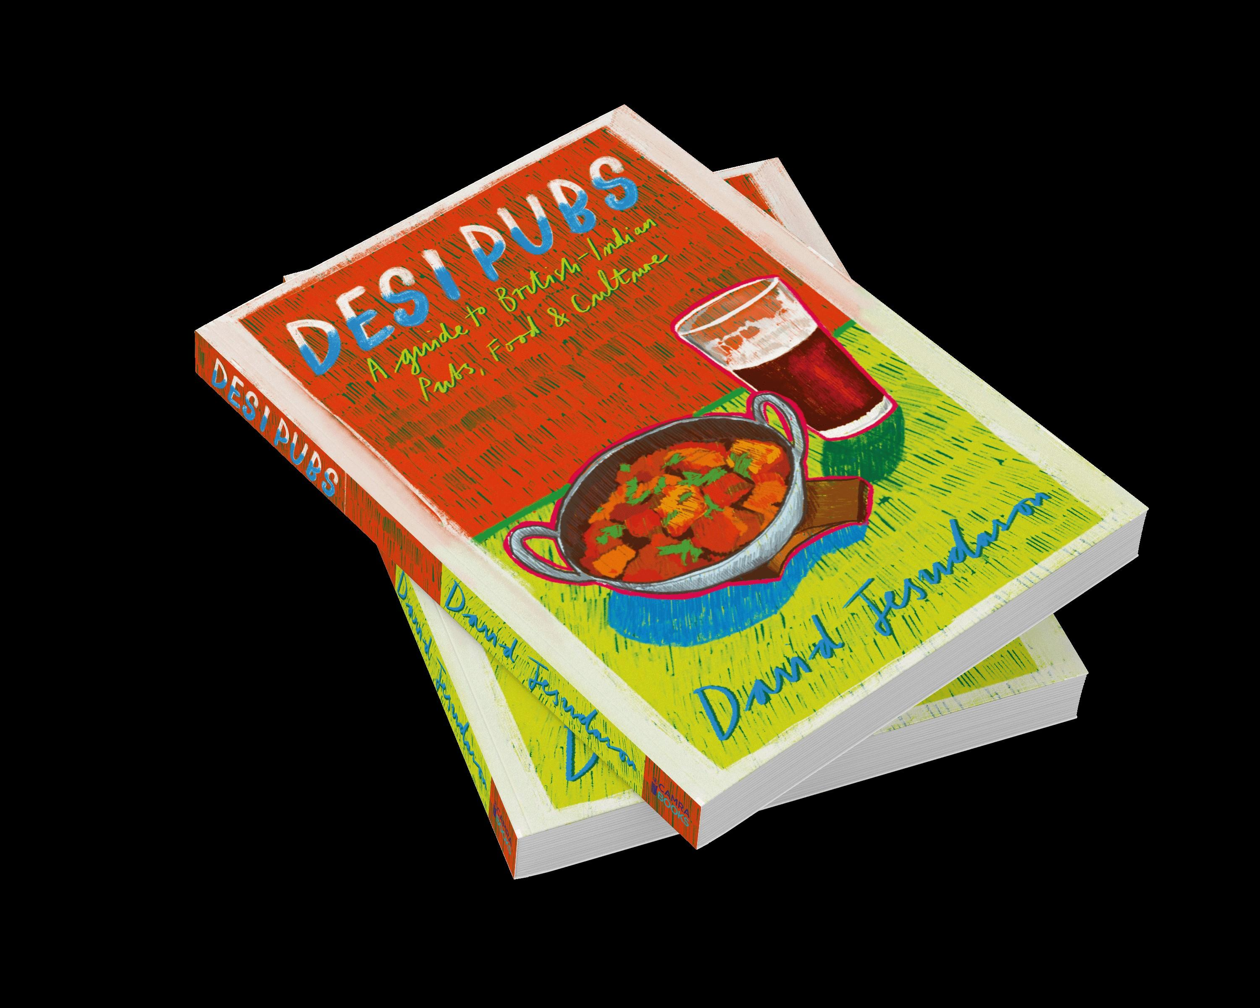

CAMRA Books’ new title Desi Pubs, written by award-winning British-Asian journalist and beer writer David Jesudason, is now on sale. The book is the first of its kind and details Jesudason’s travels across the length and breadth of the country, featuring more than 60 desi pubs in detail, run by British-Indian people who have stamped their unique identity on a beloved institution and changed our preconceptions of the publican. The desi pub began as a story of resistance. First established in the 1960s to break the racist colour bar, which saw many non-white customers refused service, they have since evolved into a modern-day celebration of multiculturalism. This is how desis – people with Indian heritage – saved failing pubs and turned them into a joyful festival of mixed grills, naans and curries all washed down with plenty of beer.   David Jesudason said: “Desi pubs show what we can achieve when we take on prejudice and fuse the best of two cultures – in this case British and Indian. They also illustrate how we can then successfully – and with little conflict – navigate a post-racism world. “This book reflects the stories behind this new beginning, as well as being a guide to the most diverse places to drink pints and eat sizzling platters. “Or, as Harry Mungali in the Black Horse, Hounslow, West London, said: ‘You don’t want this to be a posh Egon Ronay guide. This has to be David Jesudason’s best desi pubs’. Let’s hope I’ve not let Harry down. “What amazed me about my journey, is I discovered the pubs I visited were as much loved by white customers and these people deserve as much praise as the British-Indian drinkers and landlords. “They saw their areas change and instead of railing against multiculturalism they embraced how their pubs became true community hubs. Yes, they love their mixed grills but they’re also the vanguard of diversity and are totally under celebrated by the media. Until now.” To celebrate the release of the book, Meantime Brewing Company, Greenwich has created a special edition Desi Pale Ale. The new brew has a strong base of mango and guava fruit flavours with a subtle coriander spice. Turmeric and bay leaves were added in the boil with Willamette hops to supply pleasant notes of pepper. Desi Pubs is available from CAMRA’s online shop here – RRP: £14.99, Member price £12.99.