Hop collection grows in new home

16/05/2023 by Timothy Hampson

Industry

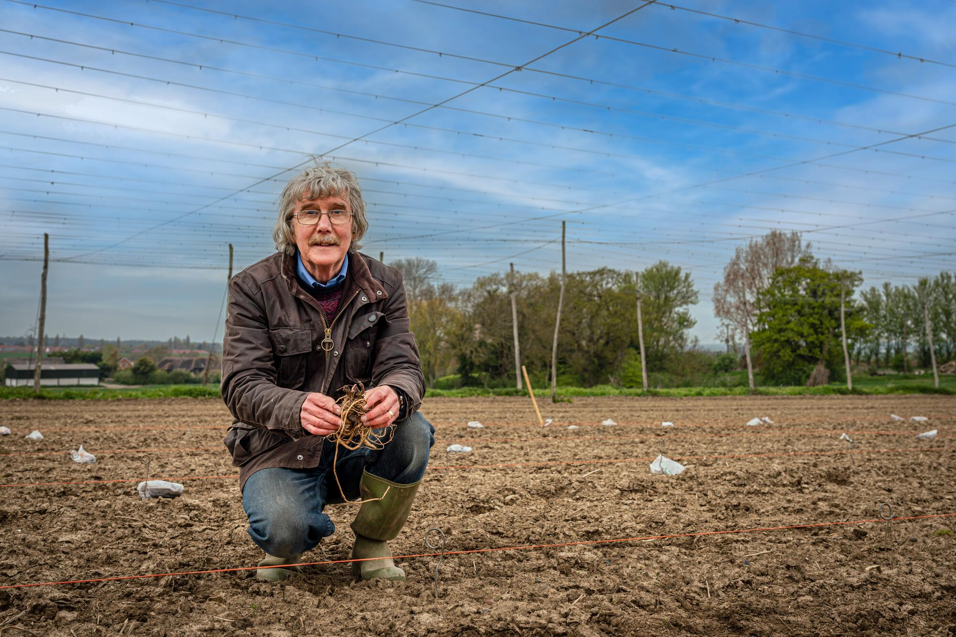

The National Hop Collection, which preserves historic varieties and provides resources to breed new ones, is to expand after moving to a larger garden with support from Shepherd Neame. The collection was originally established at Wye College in Kent, but after the its closure in 2007, it moved to land provided by Shepherd Neame at Queen Court Farm in Ospringe, near its brewery in Faversham. It was accredited as a National Hop Collection in 2010, and has grown significantly during the past 14 years, so more space was needed. A new site at Homestall Farm in Faversham was identified, owned by hop grower Antony Redsell and, after months of preparation, the move was completed in late April. The relocation has been led by Dr Peter Darby, (pictured) who founded Wye Hops which oversees the collection. He was director of research until his retirement in 2020. He said: “I am incredibly proud of everything we have achieved with the collection, so when the opportunity arose to move it to a bigger site where it could be enlarged and improved, I wanted to get involved as it felt like a fitting way to finish my work with Wye Hops. “We were grateful to receive such generous support from Shepherd Neame, which pledged not only to fund the move but to continue providing a significant annual contribution to its establishment and maintenance for at least the next five years.” Darby led a team of 10 in moving the collection to Homestall Farm, including Wye Hops’ new director of research Klara Hajdu and farm manager Peter Laslett. Once all the hop plants were at the new site, they were laid in lines noting variety and location. They were then put in the ground and covered in mulch to suppress weeds. New strings will be put in place to horizontal wires across the field, so the hop bines can grow over the coming months. Darby added: “Homestall Farm was a hop garden around four years ago, and has lain empty since then, so it is great soil for the collection to grow in. We expect to see shoots in around six weeks, then by the end of next year we hope that they will have grown to the top of the strings. We hope to offer guided tours from 2025.” Thanks to the additional room at Homestall Farm, the collection has already been able to expand from 250 to approximately 360 historic varieties of hops, mostly British, with its oldest, the Golding, dating from 1790. Darby said: “It’s an important genetic bank, preserving the traits and characteristics used in hop breeding. When it comes to breeding, I see each hop as like a key on a genetic piano. The more notes available when you play, the more interesting the sound you can create.”