Misunderstood beer name changed

15/05/2023 by Timothy Hampson

Industry

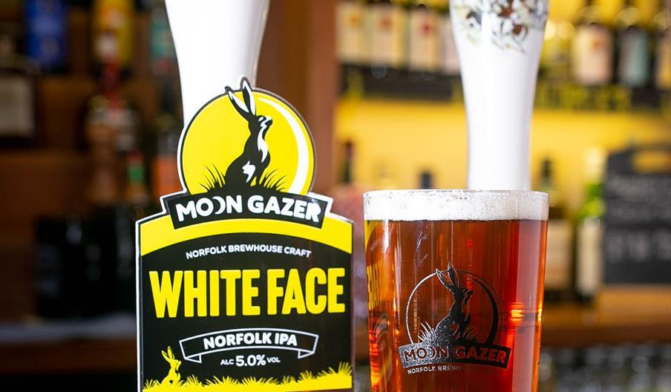

Moon Gazer ales has bowed to public pressure and changed the name of its champion cask ale of Norfolk White Face to Cheeky Jack after comments about its discriminatory connotations. The brewery, based in Hindringham, Norfolk, has become well known for its beers which are named after, or have links to, hares. Beers such as Jigfoot, Pintail and Nibbler seemingly developing their own characters, taken as they are from a centuries-old, middle-English poem called the Names of the Hare. Brewery owner David Holliday said: “We have become aware that the name White Face just wasn’t sitting entirely comfortably with some people, especially with those who are not familiar with our wider links to hares. “Winning the award saw a big increase in the distribution of the beer – but with it becoming ever more present in pubs, feedback to the name has also become more apparent. “Some people did not know the connection to the hare name, and the white mountain hare – and sadly in some cases giving rise to the feeling that there was an undercurrent of racism. “This is, of course, a complete misunderstanding – but the fact that it created that impression was of genuine concern to us.” However, it was when David and his wife Rachel overheard a conversation in a pub beer garden which finally tipped the balance: “We overheard a man showing his pint to his beer buddy and proclaiming, ‘Now, this beer is totally lush”. There was a short pause before he continued “name's a bit racist though”.  This really made us stop and reflect.” David admitted the team was conscious of being accused of being oversensitive or overreacting but countered that with the view that beer should do one simple thing – that is to bring pleasure – so if the beer, or more accurately its name, was moving away from that, however small, for them, it was time for a change. “So, going forward the beer’s name has been changed from White Face to Cheeky Jack.” The name was chosen since it’s a play on the American name for a hare – Jack Rabbit. The beer is an American-style IPA and uses lots of US hops to give it its flavour and so it seemed to be appropriate. So, what makes this IPA a Norfolk champion? It is a 5 per cent ABV, hoppy golden ale, brewed using Norfolk-malted Maris Otter extra pale which gives it a light, golden colour and a sweet, biscuit malt base. A combination of American and UK hops creates a rich, satisfying blend of mango, orange, pineapple, and peach flavours. The beer is also brewed to be gluten-free, keeping in all the flavour but removing that element. “We want people to embrace the new name, embrace the beer and embrace it for what it is, we are genuinely sorry for any misunderstanding and any offence which has been caused,” said David.