Boost for Scottish brewer’s visitor experience

22/04/2023 by Timothy Hampson

Industry

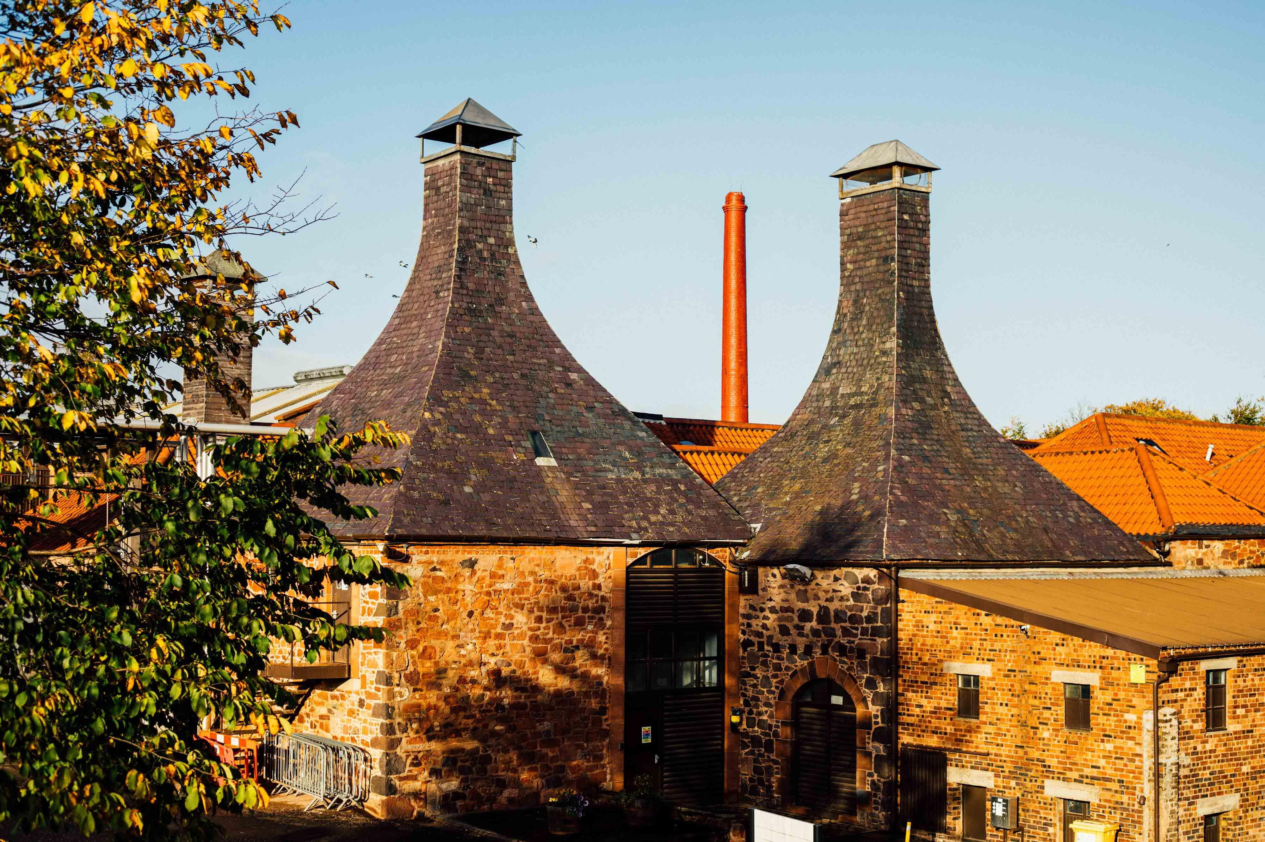

Scotland’s oldest working brewery Dunbar’s Belhaven has a new addition to its trophy cabinet as it has been given VisitScotland 4 Star Quality Assurance status for its visitor experience. Having only opened its doors in 2021, this is a significant win for the brewery (above), which has worked hard to bring the story of this historic home of Scottish brewing on East Lothian’s coastline to life. Belhaven brand manager Fiona Matheson said: “We are bursting with pride to have received such good news for our brewery visitor experience. As the summer months approach, we’re looking forward to welcoming visitors to the brewery to enjoy the experience along with a taste of some of our beers.” VisitScotland regional director Neil Christison added: “Congratulations to Belhaven brewery on achieving a 4-Star QA Award. Belhaven has been a fantastic addition to the tourism offering in Dunbar and East Lothian since it first started welcoming visitors for tours in 2021.”