Women in brewing focus for latest CAMRA podcast

20/04/2023 by Madeleine Hardman

Campaign

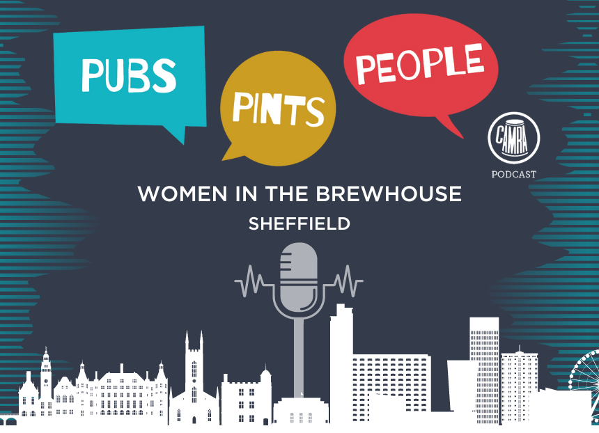

The popular CAMRA podcast Pubs. Pints. People. continues its sixth season with Women in the brewhouse, an episode that shines a light on the key roles they play in brewing and in the beer and cider communities.   Listeners can hear from Tara Nurin, author of A Women’s Place is in the Brewhouse: A Forgotten History of Alewives, Brewsters, Witches and CEOs. The hosts also explore the topic of women in beer and cider today and in the future, highlighting Jules Gray from Sheffield’s Hop Hideout, Jaega Wise of Wild Card brewery and the upcoming Women on Tap Festival at the end of May.   The episode is hosted virtually by CAMRA’s Sheffield branch, the city CAMRA’s Members’ Weekend, AGM and Conference is taking place from 21-23 April. The hosts interview Dave Pickersgill, chair of the committee charged with organising the event.  The podcast also features Jenny and Kenny Burton who have created the Real Ale Finder app, which provides digital listings of draught beers and ciders for display in bars and online.  The episode is now available on Spotify and Apple Podcast and wherever you get your podcasts. You can listen now by visiting https://shows.acast.com/pubspintspeople