New home for brewing archive

19/04/2023 by Timothy Hampson

Industry

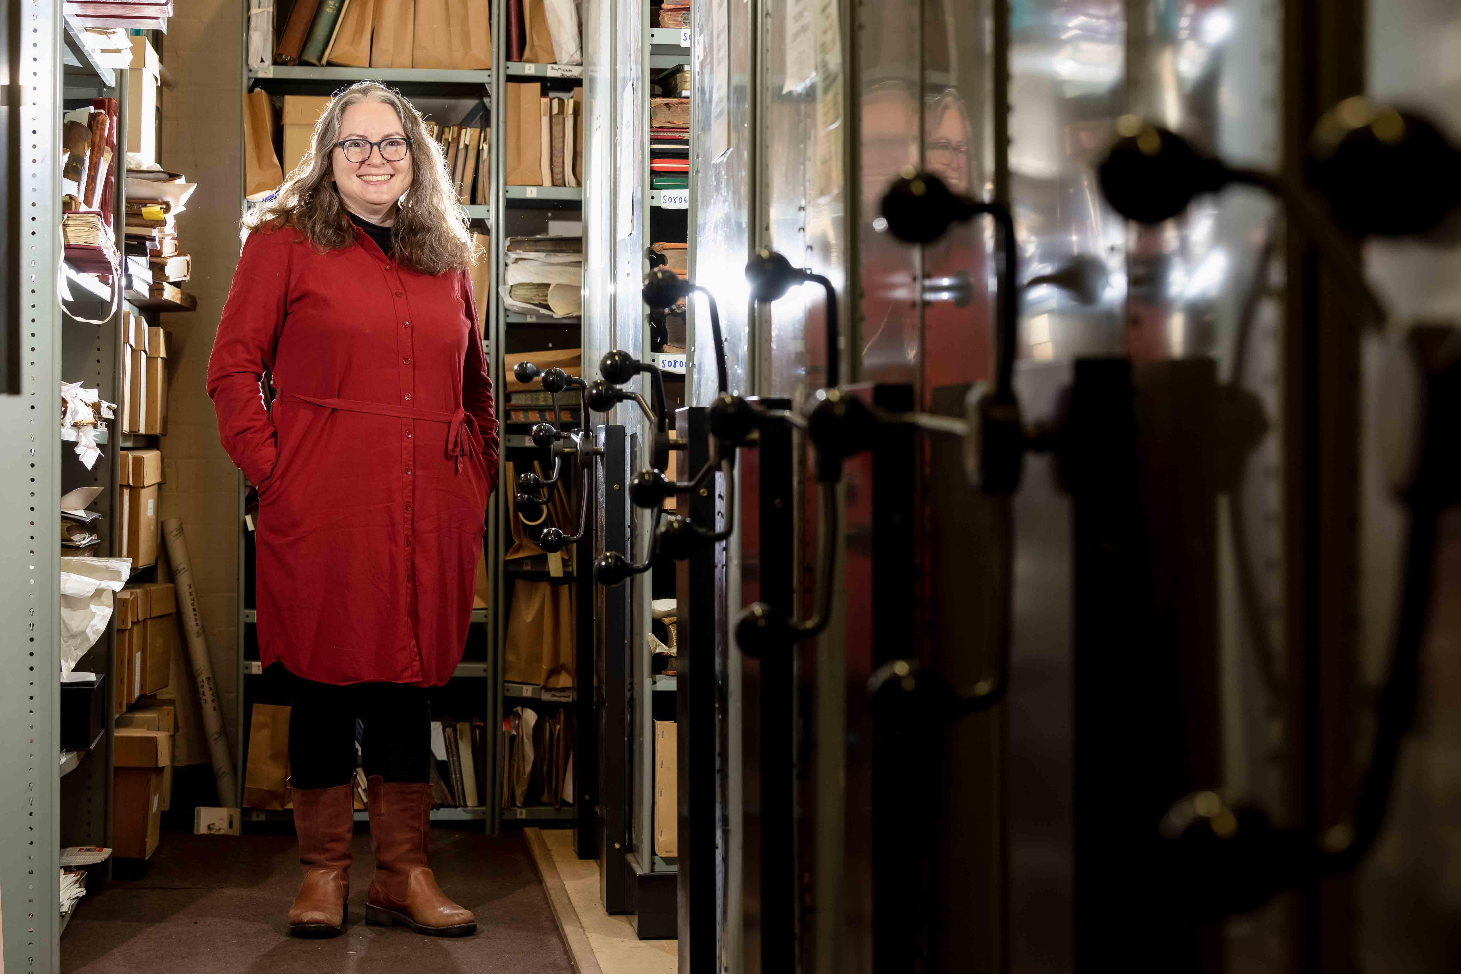

A new museum to showcase the history of brewing in Burton-upon-Trent could be open by 2025. It would replace the National Brewery Centre in the town which closed in October despite opposition. The National Brewery Heritage Trust has appointed Laura Waters (pictured) as collections officer to help it oversee the protection and preservation of the archives and artefacts which make up the National Brewery Collection (NBC). Waters has decades of experience at museums and heritage sites across the UK, including Buxton Museum and Art Gallery and the National Trust. Her immediate priorities will be overseeing the relocation of the collection and working with East Staffordshire Borough Council (ESBC) and other stakeholders to shape its future. As part of the role, which is being paid for by Molson Coors, Waters will support a team of volunteers currently working to catalogue and pack all the archives before they are moved to a temporary new home in Station Street, Burton. The volunteers include amateur archivists and engineers from the area, many of whom have years of experience in maintaining historic artefacts, vehicles and brewery equipment, alongside employee volunteers from Molson Coors. The painstaking process of creating a comprehensive inventory of all the documents and exhibits held within the NBC has uncovered some rare items including journals documenting experimental brews, photos including hundreds of images of Charrington pubs and a video archive of Carling TV ads. Waters (pictured) said: “I’m excited to be joining the National Brewery Heritage Trust at such an important time. As well as the vital work of relocating the collection and securing its future, I’ll be working with the volunteers to ensure everything continues to be safe and well maintained. “I’ll also be ensuring that the archives are accessible to the public, initially online, but then very much in person when they’re safely relocated into Station Street.” National Brewery Heritage Trust chair Harry White said: “Our charity exists to protect and preserve our unique brewing heritage. We are currently working hard on securing the future of the archives and artefacts which together make up the National Brewery Collection. We are delighted to welcome Laura to the team. She brings a level of professionalism and expertise that will be hugely valuable in the months and years ahead as we ensure the collection remains intact, in Burton and accessible to the public.” The trust is ensuring the archives and artefacts are moved in line with relevant national standards. Once packed, the items will be stored in the temporary home before moving to the proposed new Heritage Centre in High Street, Burton. The collection is being moved to enable the current building to be converted into a new head office site for Molson Coors, while its current site is redeveloped as part of ESBC’s plans for Burton town centre.