Welsh pub grows community links

18/04/2023 by Timothy Hampson

Pub

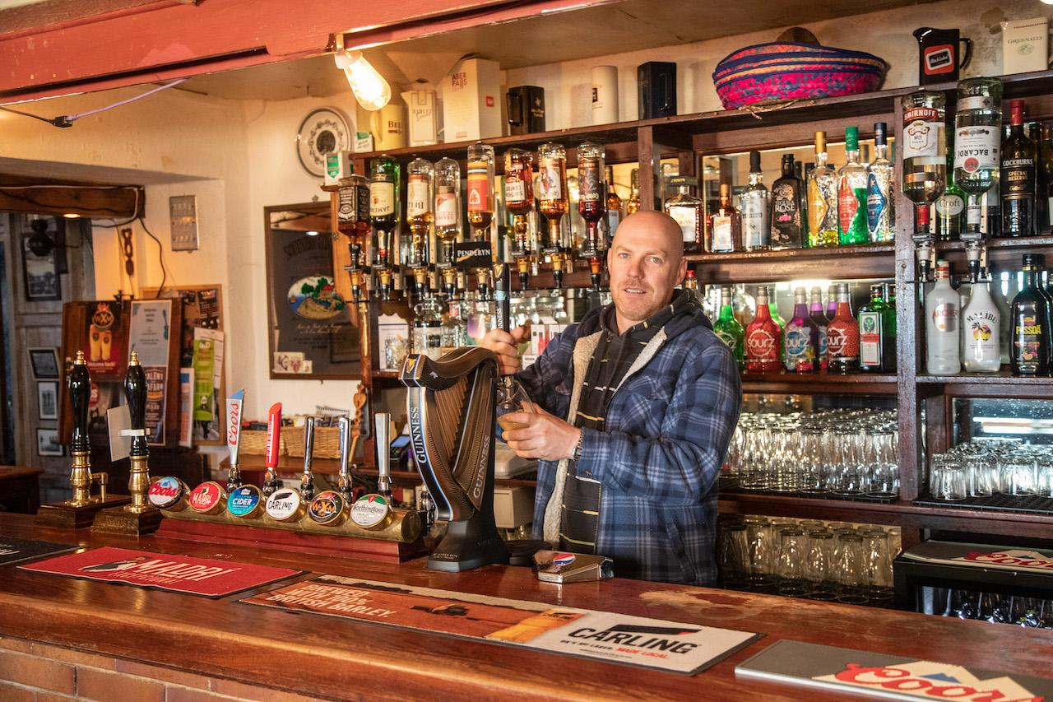

If licensee Siôn Jones (pictured) is not pulling pints, then he is likely to be pulling weeds in his pub’s new garden. The Tafarn y Plu, which is also known as the Feathers Inn, in Llanystumdwy, Gwynedd in North Wales, has extended its community garden and allotment to help residents get together and help combat loneliness and isolation.  Expert help and a Community Services Fund grant from Pub is The Hub was provided to help with the purchase of raised beds, creation of a sensory garden and improved pathways to make the garden more accessible. Volunteers from the village gave more than 70 hours of their time to help develop the garden in time for spring.  There are now also opportunities for more volunteers, including those with limited mobility, to be involved in the upkeep of the garden. There are also plans to get the garden’s sensory and wellbeing area ready, which is near a former chapel on the site. There are also moves for the local primary school to help with the raised beds to educate and show children how to grow their own food.  The pub is in former prime minister David Lloyd George’s home village of Llanystumdwy. It was purchased by members of the community in 2019 which set up a community benefit society called Menter y Plu.  This is the second pub to be supported in diversifying its services as part of a new two-year programme for Wales from Pub is The Hub in partnership with The Prince’s Countryside Fund. Pub is The Hub, the not-for-profit organisation that helps pubs to diversify and provide essential services, is supporting projects in rural areas across Wales after receiving £25,000 from The Prince’s Countryside Fund. Jones said: “This community garden will give people the chance to grow their own food in a safe and friendly environment. The raised beds, along with the new accessible pathway, means the project can include everyone from older people with mobility issues, to the disabled to young children. “We also have plans for a self-service garden hut, where people can leave a donation and purchase fresh food grown in the garden. The contact offered by gardening in an allotment environment will be a great help to combat social isolation in this rural area.” Wales regional advisor for Pub is The Hub Malcolm Harrison said: “This community garden will be an ideal place for people of all ages to get together and socialise.  “This pub is the hub of its community and is helping people form friendships and connections in a healthy, outdoor environment. We are continuing to help pubs in Wales to diversify to help their communities whether that is projects such as gardens, village stores or cafés.”  As well as the community garden, the pub is used for many other social and community activities. The book club, darts team, tea and cake afternoons, IT and learn Welsh groups, table tennis and monthly clothes exchange all take place at the pub.