No slip-ups for banana bread winner

12/03/2023 by Timothy Hampson

Industry

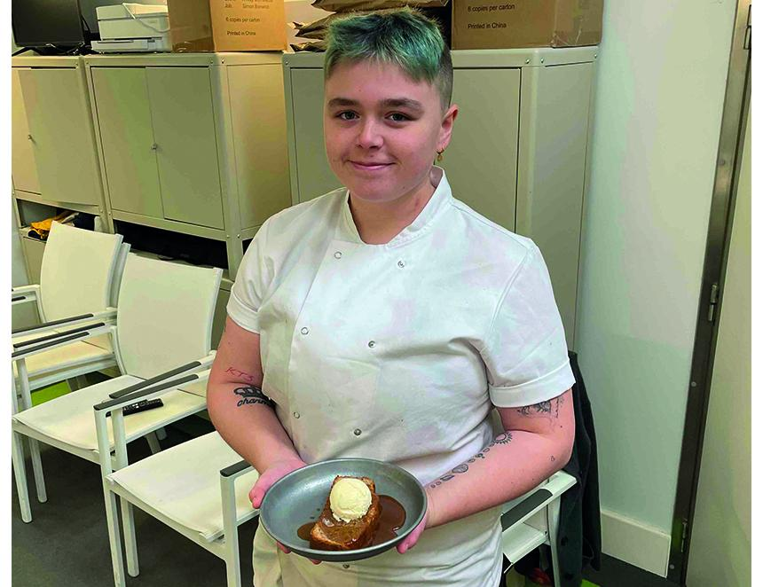

Fuller Smith & Turner’s first International Women’s Day food competition was sweet success for one of its pub chefs when her dessert dish won. The banana bread from Kiah Enticknap (pictured) of the Queen’s Head in Kingston is now taking pride of place on menus across Fuller’s managed pubs and hotels during March. A 50p donation for each dish sold, facilitated by Work for Good, will be given to Refuge, the country’s largest single provider of specialist support to women and their children experiencing domestic abuse. Eight chefs from across the Fuller’s estate took part in the competition with dishes featuring a plethora of ingredients from rabbit to sea bass. Fuller’s food marketing manager Ella Cranmer said: “I’m so pleased to have launched this competition. While we have some amazing role models through chefs like Angela Hartnett and Claire Smith, women are still underrepresented in Britain’s kitchens. “Raising their profile with great competitions like this is one way we can highlight the amazing female role models across the Fuller’s estate. “It’s also great to be raising money for Refuge as a result – all women should be celebrated, and we wanted to make sure that the inspiration and talent of our female chefs can be used to help give a better life to women who are suffering abuse.”