Fears for future of Jennings artefacts

07/03/2023 by Timothy Hampson

Campaign

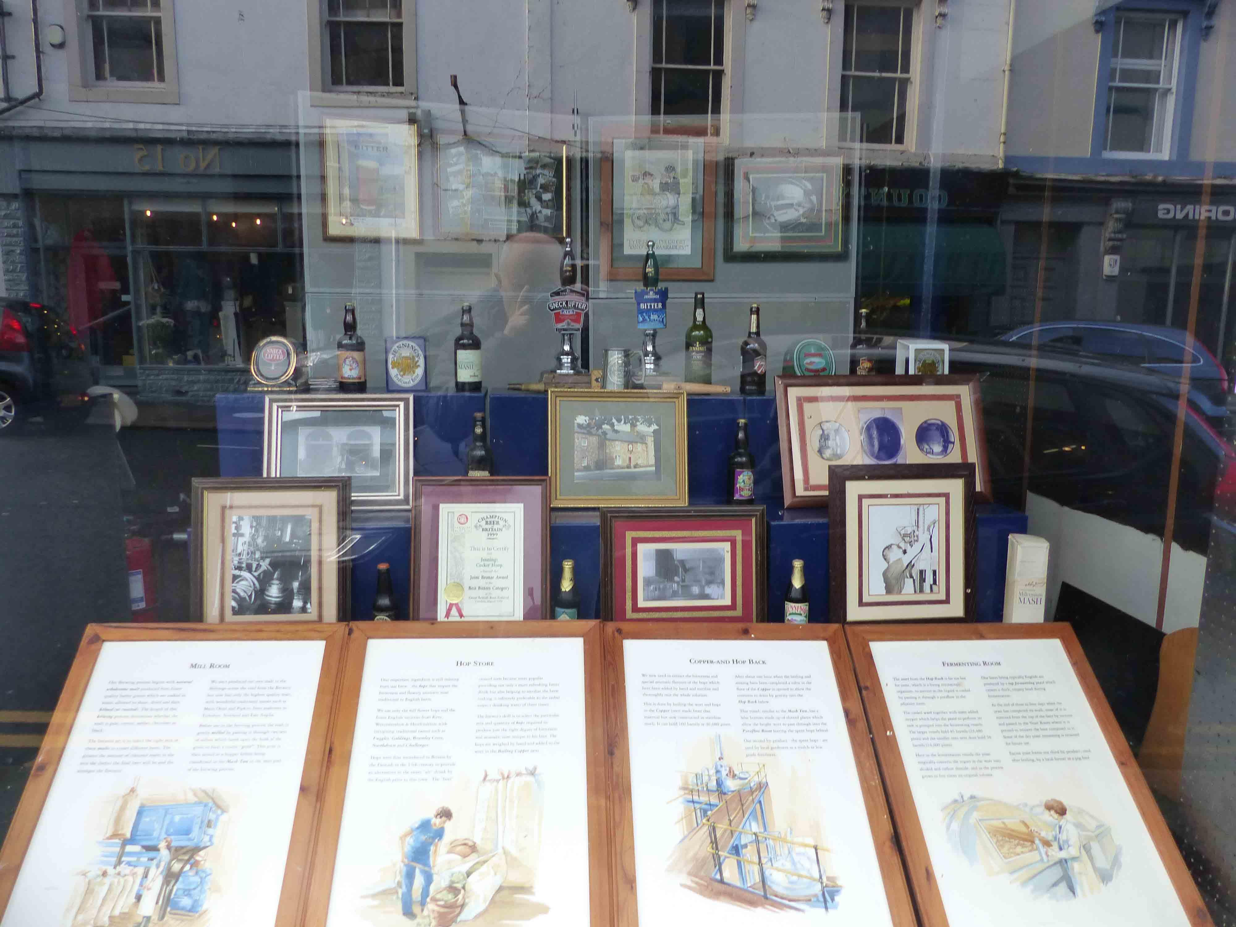

CAMRA’s West Cumbria branch has raised concerns over the future of historic artefacts from the recently closed Jennings brewery in Cockermouth. The branch had arranged a two-month display of photos and other objects from the brewery (pictured), which was closed by Carlsberg Marston’s (CM) last year. Once the exhibition in a local shop was finished, the branch planned to distribute the objects to pubs keen to put them on permanent display. West Cumbria spokesman Len Wainwright said: “[We] were somewhat surprised when following the two-month successful exhibition Carlsberg Marston’s demanded that all the objects be returned to the brewery. “The plan put to CM was to stage an exhibition in Cockermouth after which the objects used in the exhibition would be distributed among Cumbrian pubs with a link to Jennings so that the brewery’s history and importance to Cumbria would not be forgotten. “Accordingly historic pub signs, posters, handpumps, bottles, brewing equipment and beer mats were catalogued, removed from the brewery and together with interpretive boards put on display.” At the end of February, the branch notified CM that the exhibition was ending and, in line with the original plan, pubs, many of which are owned by CM, would be contacted to see if they wanted any of the objects to display in their pubs. Len said: “CM’s response was too tell the branch to return the objects to the empty brewery. No reason was given by CM neither did CM state what it intended to do with them and the branch fears without a plan for their future they will simply end up in a skip. It seems CM doesn't care about the heritage and legacy of the breweries it takes over and then close.”