Campaign to save historic inn gathers pace

02/03/2023 by Timothy Hampson

Pub

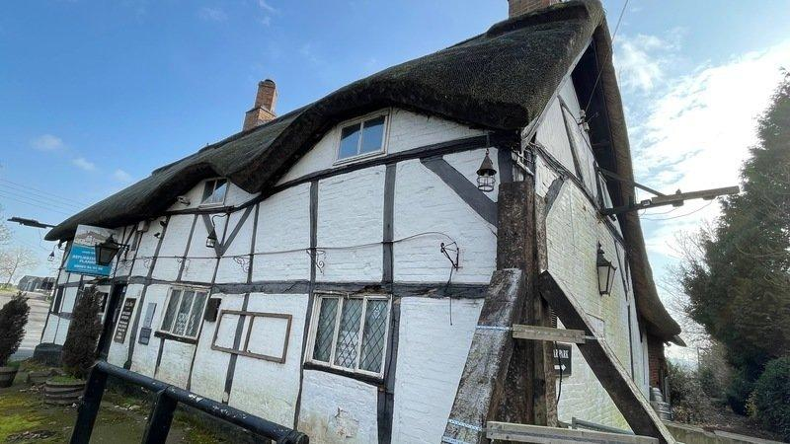

Residents of Sibson, near Hinckley, Leicestershire are taking action to save their 750-year-old village pub, the Cock Inn. The Grade II-listed pub closed in November 2019, much to the disappointment of villagers. At the time, owner Star Pubs & Bars applied for planning permission for repair works to the windows, roof and other areas, to “stabilise the building”. The work has not yet begun, and residents are fearful for the future of the historic pub. A public meeting was called and a petition launched to help save the building as a pub. Pub campaigner Jonathan Collett said: “The Cock Inn is registered as an Asset of Community Value and has been deteriorating since being left vacant in November 2019. It is a much-loved landmark in the area and a much-missed social hub for locals and visitors alike.” Already, more than 600 people have signed the petition. What’s Brewing contacted the pub’s owner, who said it planned to spend £150,000 preserving it. Star Pubs & Bars stated: “This (work) will involve taking down an exterior retaining wall to rebuild the pub using traditional materials and in a sympathetic way. “Getting the necessary planning permissions to carry out the works and finding a specialist contractor to undertake them has been time consuming. We now hope to be able to get on site and start the works as soon as possible and before the summer. “Once this essential renovation work is completed and subject to recruiting a new operator, we would like to undertake a major £225,000 plus refurbishment to transform the Cock Inn into a characterful coaching inn, offering something for everyone. "The Cock Inn is blessed with original features including exposed beams, open fireplaces, and cosy rooms. The refurbishment would retain these features and highlight the pub’s traditional character and charm, whilst sympathetically upgrading it, making it more welcoming and comfortable and adding new contemporary furniture. “An al fresco area would also be added at the rear of the pub. This site offers excellent potential to a licensee looking to create a great pub known for its food and drink. “We are currently confirming the final details of this project including availability of the necessary labour to carry out the works. We are keen to get on site as soon as possible and hope to have a schedule finalised imminently, which we will be happy to share. As a wall is coming down, the works also rely on good weather." Anyone interested can find out more at www.starpubs.co.uk or call 08085 949596.