Hall effect still working well after 40 years at Oxford pub

24/02/2023 by Timothy Hampson

Pub

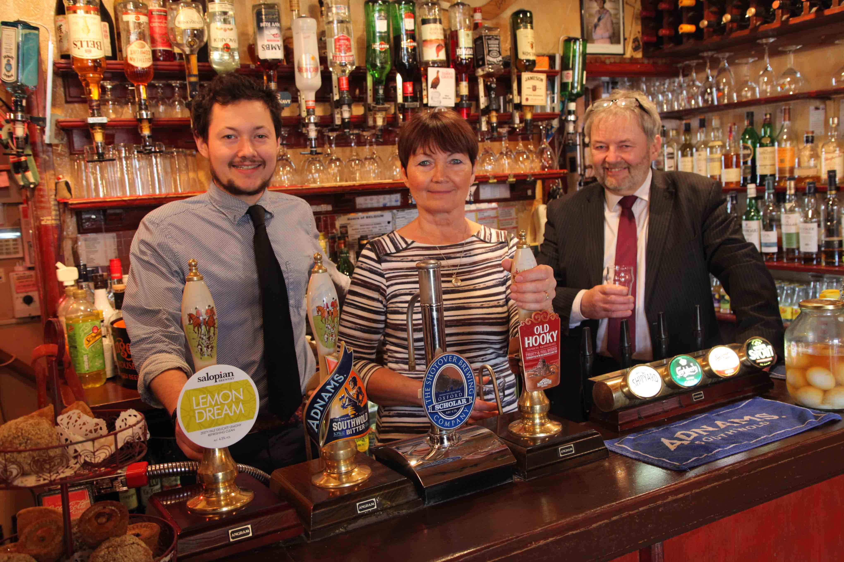

Real ale campaigners have joined the tributes to Andrew and Debbie Hall who celebrate 40 years running the Rose & Crown in Oxford. The couple — who run the pub in the north of the city with son Adam — have created a special cask ale at Hook Norton brewery to mark the occasion and are keen to reassure their many regular customers that they have no plans for retirement. Oxford branch spokesman Dave Richardson said: “The Hall family are the perfect landlords for what many would regard as the perfect pub — traditional in every respect, with the emphasis on real ales, a wide range of other quality drinks and unpretentious food. “There are no TVs, no piped music, no slot machines and nothing to detract from the warmth of their welcome and the opportunity to talk to friends old and new. “The Rose & Crown has been in CAMRA’s Good Beer Guide every year bar one since 1997, and always serves at least two local ales. We look forward to sampling the 40 Years Bitter they have just helped brew.” The story began in 1983 when they took over a pub then owned by Ind Coope, part of Allied Breweries. When legislation was passed in 1989 to reduce the power of the big breweries by forcing them to sell many pubs, the Rose & Crown was taken over by a succession of pub-owning companies which, Andrew said, were only interested in their value as property. He told the Oxford Drinker website: “One day Debbie took a call from the pub company telling us the rent was going up from £12,500 to £36,000 a year. We were crying with worry. We had a young son – how were we going to pay the rent, let alone make any money?” Years of struggle followed as Andrew became a lobbyist for a better deal for pub tenants, until in 2009 they were finally able to buy the pub from Punch Taverns. Being their own bosses made all the difference, especially during the Covid lockdowns. Adam now runs many aspects of the pub including all the cellar work, ordering supplies, organising staff and accounting. Their daughter Annabel, a wedding planner, joined Adam during lockdowns for home delivery of cask ale and food. Debbie and Andrew still work 12-hour days six days a week, Debbie running the kitchen while Andrew, in his own words, “oversees and entertains”. “We don’t really regard 40 years here as a great achievement, as it’s such a wonderful place to work with such wonderful and varied customers,” said Andrew. “It’s really been a team effort, and wouldn’t have been possible without Debbie, Adam and all the great staff who have supported us over the years.” Adding to the tributes Hook Norton MD James Clarke said: “I know how hard the pub trade is, and to be in the same pub for such a long period and still making it a place where people want to go and relax is a massive achievement. We are honoured to help Debbie and Andrew brew their anniversary ale.” Pictured from left: Adam, Debbie and Andrew Hall