Sunderland pub celebrates three decades in top guide

04/11/2022 by Ken Paul

Campaign

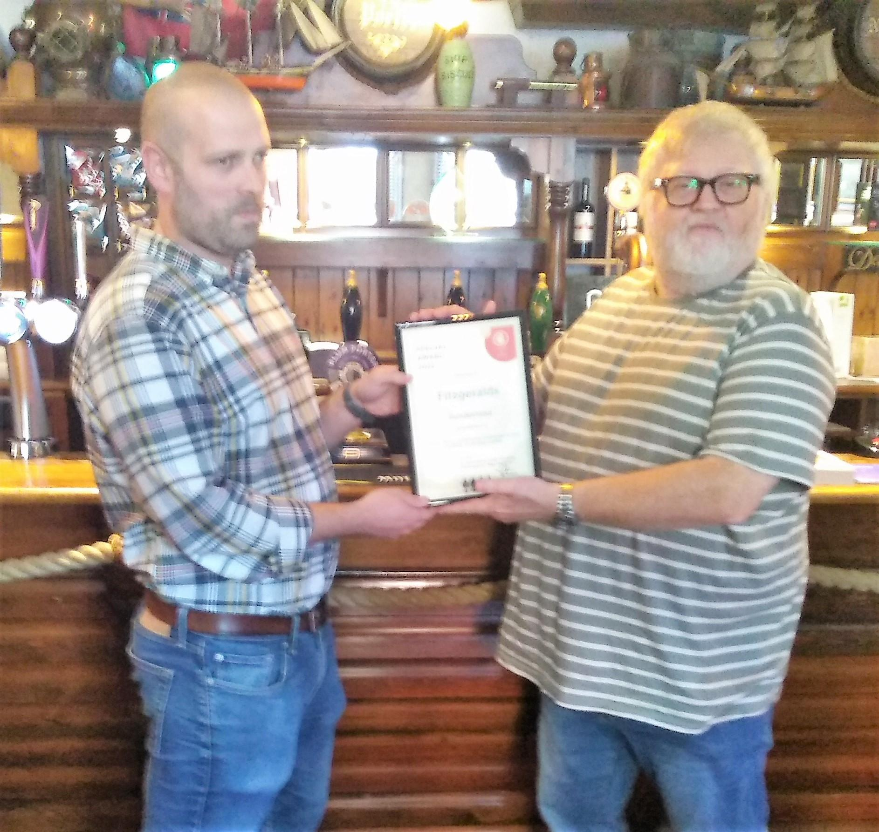

The launch of the 2023 Good Beer Guide prompted Sunderland & South Tyneside CAMRA branch to mark the remarkable achievement of one of its pubs which notched up its 30th listing. At the guide’s launch in Fitzgerald's in Sunderland city centre, Fitzys’ manager Matty Downes was presented with a certificate to mark the 30 continuous years in the guide by branch chair Ian Monteith Preston. Pictured: Matty Downes, left, receives Fitzys’ award from Ian Monteith Preston.