Micropubs celebrate first Good Beer Guide listing

20/11/2021 by Ken Paul

Campaign

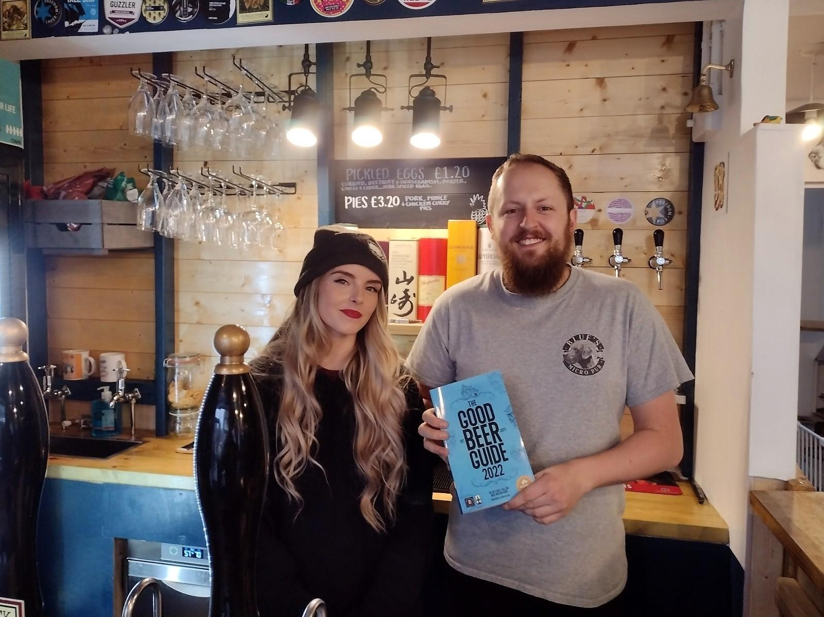

With Covid-19 preventing the North-East’s usual Good Beer Guide launch, Sunderland and South Tyneside branch decided to do something at a more local level. The branch has 22 entries in the guide making visiting them all impossible, so it focussed on the two new entries. Both are independent micropubs and this was the first year either had qualified for the branch’s guide consideration. The first pub visited was Blue’s in Whitburn on the coast between South Shields and Sunderland. A small group of branch members met with owners Callum Watson and Alice Pye (above) for a chat and to congratulate them on their listing.

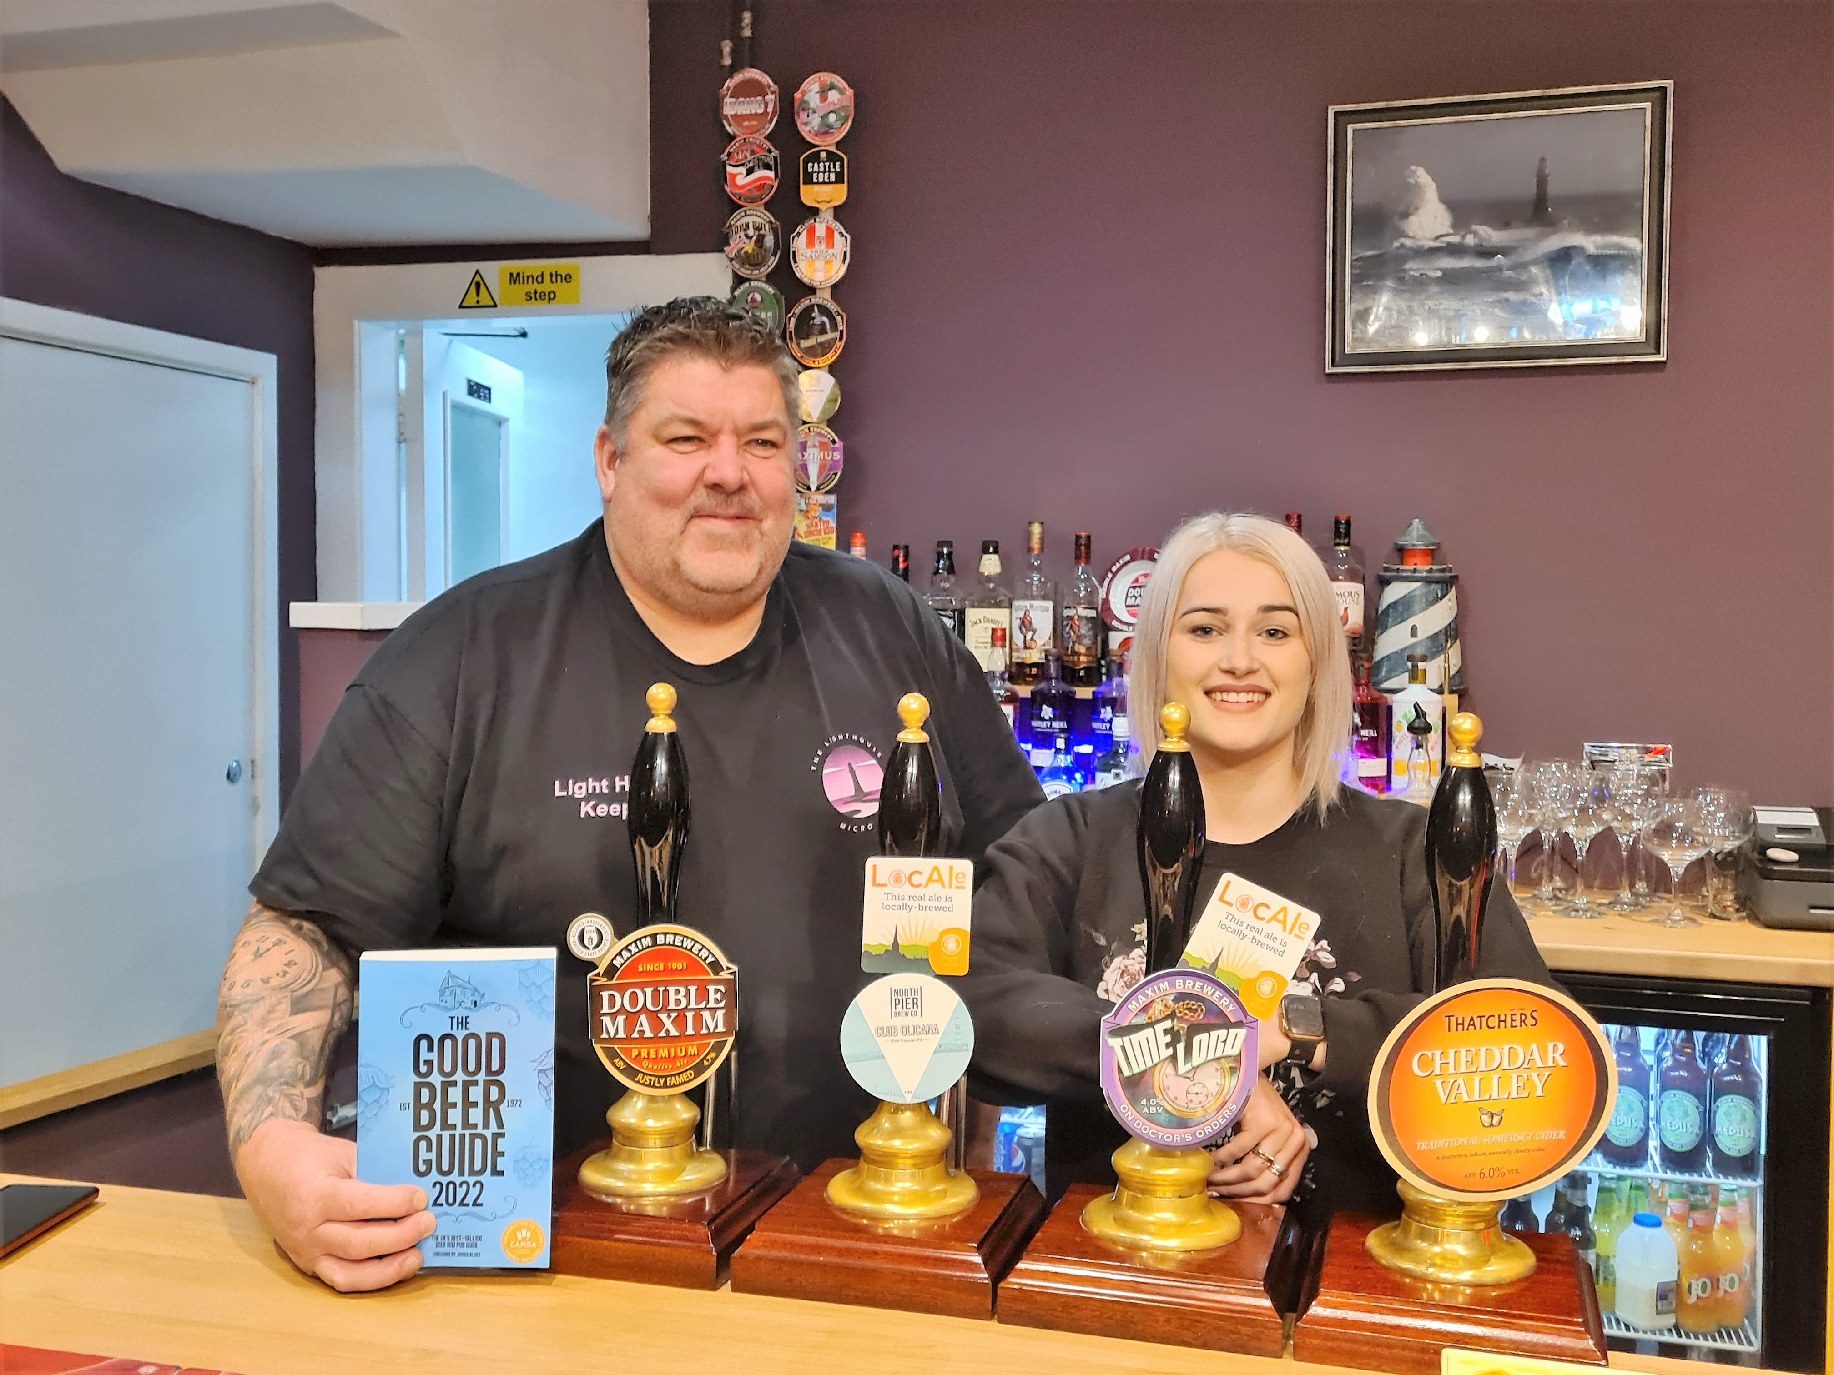

The second was the Light House in Fullwell, Sunderland. Members caught up with owner Sean Turnbull (pictured with colleague Becca). Sean may be relatively new to owning a micropub but he is well known to the branch as he was a drayman for local brewery Maxim. Thanks to Ian Monteith Preston. Photographs by Ian Monteith Preston and Robin Sanderson