Blunt celebrates great pubs in latest Good Beer Guide

27/09/2021 by Timothy Hampson

Campaign

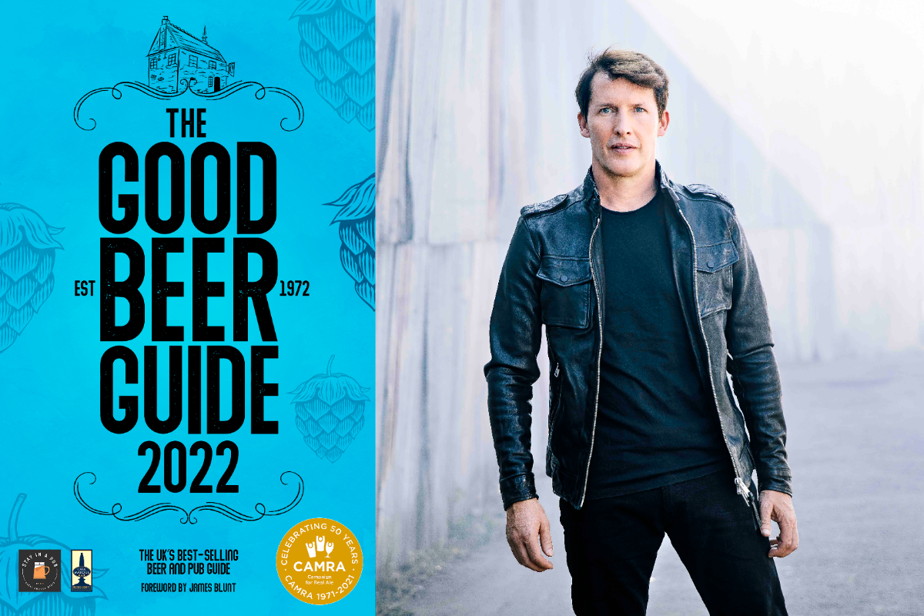

Best-selling singer James Blunt has thrown his support behind the great British pub and reflected on the industry’s struggles during the coronavirus pandemic, in his foreword for CAMRA’s Good Beer Guide 2022, due to be released on 12 November 2021. Following 18 months of struggles for the industry in the face of restrictions and lockdowns, Blunt, who owns the 17th-century Fox & Pheasant pub in Chelsea, remarks that as both a musician and a publican, he has “pretty much chosen the worst two jobs for a global pandemic”.  However, with his trademark optimism, he highlights the importance of pubs to communities and encourages Brits to get back to the pub to support their locals, writing: “Whilst, in recent years, there might have been a trend for people to drink cheap supermarket beer at home, those people have been locked away for the best part of a year, and now those people want out. “They can taste real beer from the tap, and food cooked by a pro, and they can meet legally and joyfully.” Blunt’s foreword, in the guide sponsored by Cask Marque and Stay in a Pub, reflects on the challenges the industry has faced, including the closure of pubs and the introduction of the furlough scheme. The ramifications of the Covid-19 pandemic are still being felt across the industry, despite the lifting of most restrictions. CAMRA national chairman Nik Antona said: “We are thrilled to have James Blunt on board, writing the foreword for this year’s Good Beer Guide. Having saved a pub from demolition and running the business, he can appreciate the struggles felt by thousands of publicans across the country during the pandemic.  “Pubs have faced a number of unique challenges since the first lockdown in March 2020, including long periods of closure, reduced turnover and higher overheads due to social-distancing measures. “As we begin to see the light at the end of the tunnel, we hope people will take James’ advice and use the Good Beer Guide to visit excellent pubs across the country. They need your support now more than ever.” Pre-orders of the guide can be made at: https://shop1.camra.org.uk/product/the-good-beer-guide-2022  Image: Michael Clement