Cask Marque sponsors Good Beer Guide

10/09/2021 by Timothy Hampson

Campaign

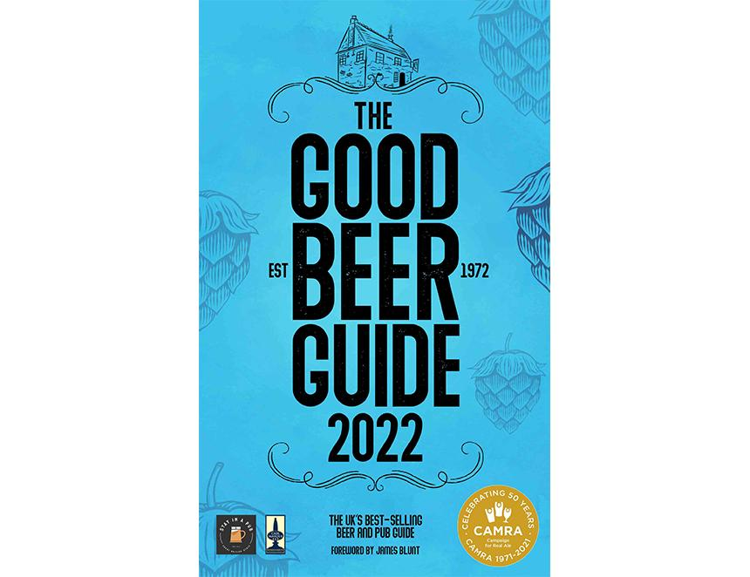

Cask Marque and its sister organisation Stay in A Pub have signed up as sponsors of the 2022 Good Beer Guide. Cask Marque founder Paul Nunny said: “CAMRA identifies some of the best pubs in the UK and those pubs in the guide which are in Cask Marque will have our symbol by the side of their entry as an endorsement. We work together to ensure consumers enjoy a great pint of cask ale. “Regarding accommodation, it is becoming an important third income stream for pubs, particularly rural, and links on the Good Beer Guide app to the Stay In A Pub website makes it easy for consumers to book and enjoy the culture and a pub atmosphere.” CAMRA chief executive Tom Stainer said: “Cask Marque has been a key player in encouraging pubs to serve cask ale at its best, so it's a perfect match for CAMRA’s Good Beer Guide, which celebrates and promotes the best of cask ale pubs. “Cask ale fans want to know where they can get their pints in the best condition, Cask Marque shows pubs how to do this, and the Good Beer Guide lets you know where to find them. “Cask Marque’s support of CAMRA has been very welcome over many years and we're especially pleased it is involved with the Good Beer Guide in our anniversary year." The guide is due to be launched on 11 November.